New Brunswick Community College 1234 Mountain Road Moncton, NB E1C 8H9

Graphic Design Newsletter
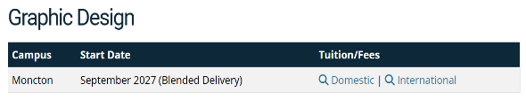
Winter Scholarship Fundraiser
Donations are still being accepted for the annual Winter Gala dinner and silent auction. This is our biggest fundraiser of the year, benefiting the Student Emergency Fund. Bring your items to Sylvia Haines, Director of Programs, no later than December 10. Her office is in the A building. We expect a large turnout for this event, so please be sure to make your reservation by calling Stacy Lu at (930) 555-1234 between the hours of 9:00 AM – noon and 1:00 PM – 5:30 PM before the deadline.

Volunteer of the Year Announcement
Joan Stephens, an energetic volunteer for our Graphic Design Student Mentors, is the recipient of the Volunteer of the Year award. Please stop by the C Building to sign a congratulatory card for her. Cards may be sent to:
Joan Stephens c/o Volunteers USE
22 Joslin Lane
Moncton, E1G 1T4
December Birthdays
Date Name
11 Mary Margolis
17 Antonio Ramirez
18 Lydia Zimmerman
20 Eleanor Robinson
27 Stepfan Richards

Volunteers Needed
We still need peer leaders for the following sessions. Please contact Abigail Gardner if you can help.
Registration 101: Navigating the Process. A session for new students
When: March 27 at 4 p.m.
Where: NBCC Campus, E Building

Communicating with your Instructors: A class for students to learn the most effective way to send and receive messages and work with attachments.
When: April 3 at 6:30 p.m.
Where: Main Campus


When you are finished with our newsletter, please pass it on to someone else to read or recycle it.

